HSC4M: World Cultures-Christianity

Name: _____________________________________ Date: March 18, 2020

HOW CATHOLICISM INFLUENCED CIVILIZATION
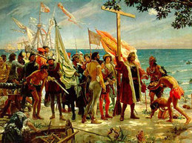
Roman Catholicism has greatly influenced civilization and has made great and amazing contributions to society throughout the centuries, while at the same time, it hasn’t always been seen in a good light. After discussing and learning about Christianity in class, you will…
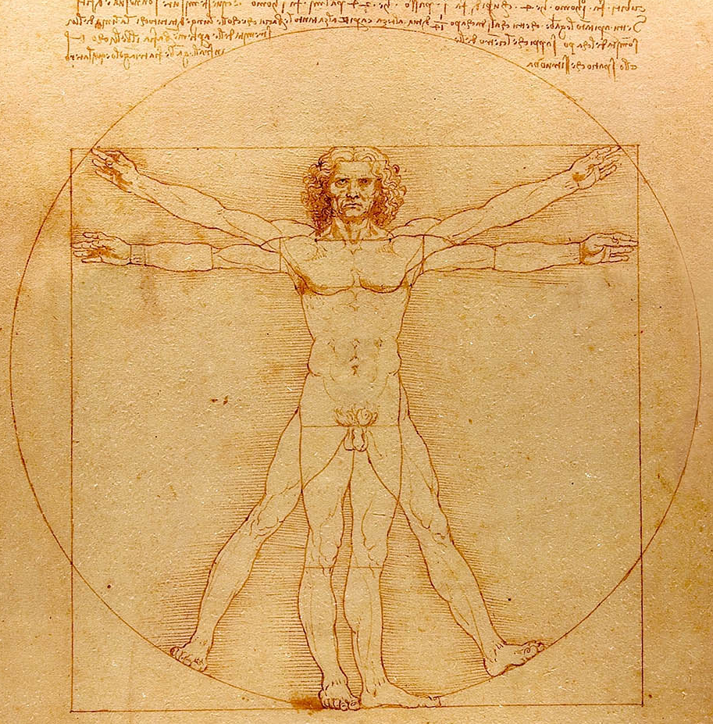
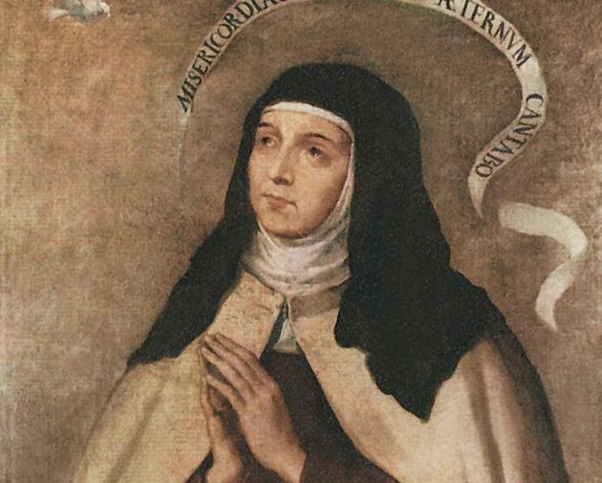

- Research: Research on the different areas on how Roman Catholicism influenced civilization. Below is a list of possible topics which you could choose from for your research:

- Catholic influence on Education
- Catholic influence in Art and Architecture
- Catholic influence in Music
- Influence in Science and Geography
- Catholic missions in China
- Catholic missions in Korea
- Catholic missions in Vietnam
- Catholic evangelization in the Philippines
- Who were the Jesuits?
- Who was Saint Teresa of Avila?
- Who was Saint Ignatius of Loyola?
- Who was Saint Francis Xavier?
- The Council of Trent

With these topic examples, you will:
- You will write an essay based on the power point slides and what you know about Christianity and its influence in culture. Your essay should be at least 4 pages and here are some following questions to guide you.

- Historical background of your topic
- How did your topic influence Christianity?
- How did your topic influence Civilization?
- How is your topic still relevant today in the 21st century?

Reminder: Do not forget to include your sources.

Due date for paper: April 3, 2020

