HSC4M: World Cultures-Christianity

Name: _____________________________________ Date: March 18, 2020

MARIAN APPARITIONS: THEIR SIGNIFICANCE IN CATHOLICISM, HISTORY AND CHRISTIAN CULTURE
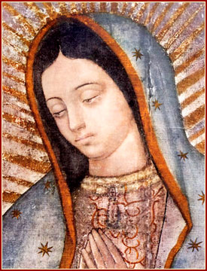
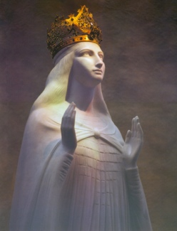
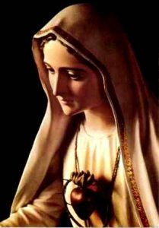
As discussed in class, Christianity has had a major impact in Western and Eastern civilization over the centuries. Major figures such as Jesus and several devotions have had influence in the enhancement of Christianity. One such important figure is Mary, the Mother of Jesus where Christians call Her as “Our Lady.” Her appearances over the centuries have influenced not only devotion to Her and to Christianity but also history and culture.

- Research: Research on the different Apparition sites of the Virgin Mary, Mother of Jesus and to familiarize yourselves on how each appearance made an impact on history and culture. Below is a list of some of the apparitions, titles and devotions to the Mother of God where you will choose one for your research:

- Our Lady of the Pillar, Spain
- Our Lady of Guadalupe, Mexico
- Our Lady of La Vang, Vietnam
- Our Lady of La Salette, France
- Our Lady of Lourdes, France
- Our Lady of Knock, Ireland
- Our Lady of Fatima, Portugal
- Our Lady of Kibeho, Rwanda
- Our Lady of Aparecida, Brazil
- Our Lady of Czestochowa, Poland
- Our Lady of Charity, Cuba
- Our Lady of Altagracia, Dominican Republic
- Our Lady of La Naval, Philippines
- Our Lady of Siluva, Lithuania
With these topic examples, you will:
1.) Write an essay representing a specific title of the Virgin Mary you have chosen from the choice list above. Here are some following questions to guide you. Your essay should be at least 4 pages long.
- The historical background of these titles and apparitions of the Virgin Mary
- What is their significance in Catholic Christianity and their importance in their respective countries.
- Did it influence the country’s culture/history?
- How did it influence Catholic culture?

Reminder: Do not forget to include your sources and cite your work.
Due date for paper: April 6, 2020

