Team Handball
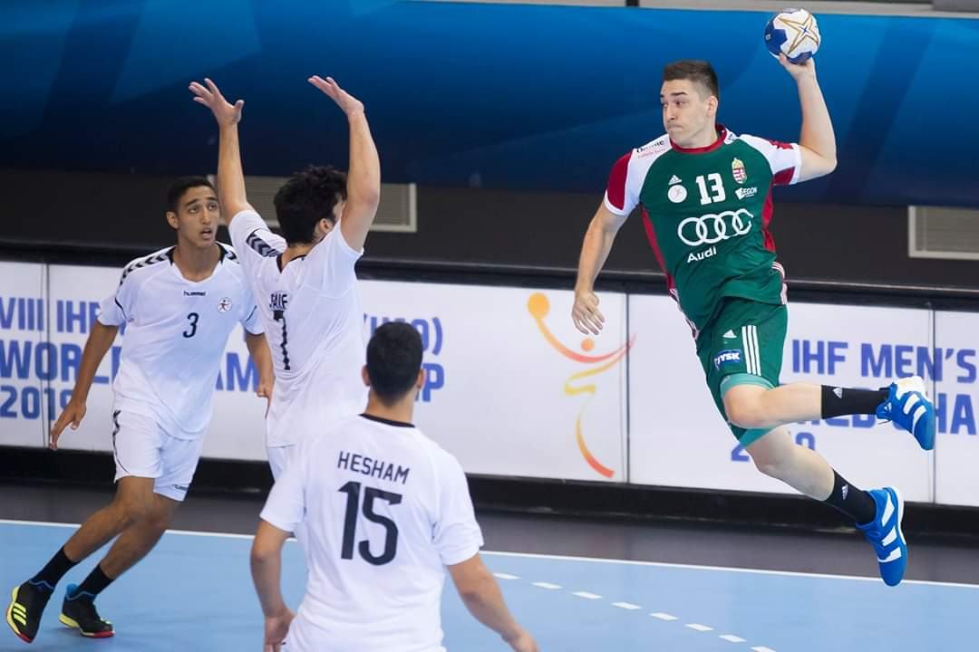

- The Rules of Handball
https://i.ytimg.com/an_webp/69Ap8WsenXc/mqdefault_6s.webp?du=3000&sqp=COD6__MF&rs=AOn4CLCLfBJC69NES96mhmqg3I_n4qSXUA

- Learn the basics
https://www.youtube.com/watch?v=G9QJSjhOgM8

- Team Handball Skills and Drills
https://www.youtube.com/watch?v=7wsgis2DK1E

- Team Handball( Game, Skills, Drills
https://www.youtube.com/watch?v=0dbOri9R8yM

- How to do Dribbling in Handball
https://www.youtube.com/watch?v=ycoJ9U36toI

- How to throw a handball
https://www.youtube.com/watch?v=uTsgTjH_p7Q

- A guide to passing in Handball
https://www.youtube.com/watch?v=tMLu3zWV3Sg

- How to practice Handball
https://www.youtube.com/watch?v=CslXSaYFEdM

Quiz: -
1)What are the rules of team handball?

2)What are the 7 positions in handball?

3)Who is the father of handball?

4) What is the handball game?

